- Supplementary Materials
Field inoculation with a local arbuscular mycorrhizal (AM) fungal consortium promotes sunflower agronomic traits without changing the composition of AM fungi coexisting inside the crop roots
Myriam Arcidiaconoª, Laura Ercoliª, Gaia Piazzaª, Elisa Pellegrinoª,*
ªCrop Science Research Center, Scuola Superiore Sant'Anna, Pisa, Italy
*Corresponding author: elisa.pellegrino@santannapisa.it (E. Pellegrino)

Supplementary materials and methods

1. PCR , amplicon purification and amplification

PCRs were generated from 10 ng μL⁻¹ genomic DNA in volumes of 25 μL with 0.125 U μL-1 of GoTaq® Hot Start Polymerase (Promega Corporation, WA, USA), 0.5 μM of each primer set for AMF, 0.2 mM of each dNTP, 1 mM of MgCl2 and 1x reaction buffer, using a S1000 Thermal CyclerTM (BioRad, Hercules, CA, USA). For both steps, the PCR cycle consisted of initial denaturation at 95 °C for 2 min followed by 25 cycles of 94 °C for 30 s, 59 °C for 45 s, 72 °C for 1 min, 30 s and 72 °C for 10 min. The quality of all PCR products was examined by gel electrophoresis through a 2% agarose gel in 1 × TBE buffer, then purified with magnetic beads (Agencourt AMPure® XP, Beckman Coulter, USA) and freshly prepared 80% ethanol. The DNA concentration was then quantified by fluorimetry with the Quant-iTTM dsDNA High-Sensitivity assay kit (Invitrogen by Thermo Fisher Scientific, CA, United States), following the manufacturer instructions.

Supplementary results

1. AM fungal community composition in sunflower roots

Twelve VTX (46%) were shared between years, while 10 and 4 VTX (39% and 15%) were unique in 2019 and 2020, respectively. In high soil fertility (2019), a total of 22 AM fungal VTX belonging to five orders (i.e., Diversisporales, Entrophosporales, Glomerales, Archaeosporales and Paraglomerales) and six families (i.e., Acaulosporaceae, Ambisporaceae, Entrophosporaceae, Glomeraceae, Paraglomeraceae, Gigasporaceae) were recovered in +M and -M (Fig. S4a). In detail, 20 AM fungal VTX were found in +M and 17 in -M (+M: four orders: Diversisporales, Entrophosporales, Glomerales, Archaeosporales; four families: Acaulosporaceae, Ambisporaceae, Entrophosporaceae, Glomeraceae; -M: four orders: Diversisporales, Entrophosporales, Glomerales, Paraglomerales; four families: Entrophosporaceae, Glomeraceae, Paraglomeraceae, Gigasporaceae). In low soil fertility (2020), AM fungal VTX belonged to five orders (i.e., Diversisporales, Entrophosporales, Glomerales) and six families (i.e., Acaulosporaceae, Entrophosporaceae, and Glomeraceae) were retrieved. In detail, 14 AM fungal VTX were found in +M and 10 in -M (three orders: Diversisporales, Entrophosporales, and Glomerales, and three families: Acaulosporaceae, Entrophosporaceae, and Glomeraceae in +M and -M) (Fig. S4b).

Table S1
Physical and chemical properties of soil at the experimental field sites in high- and low-fertility sites (High-fert and Low-fert, respectively). Soil depth of 0-20 cm.
Propertiesª | High-fert^{b} |  | Low-fert
Sand (%) | .53.9 ± 0.4 b^{c} |  | 23.4 ± 1.9 a
Silt (%) | 35.4 ± 0.94 a |  | 54.7 ± 0.9 b
Clay (%) | 10.7 ± 0.62 a |  | 21.9 ± 1.1 b
pH | 7.5 ± 0.1 a |  | .8.0 ± 0.1 b
SOC (g kg⁻¹) | 75.0 ± 9.9 b |  | 9.6 ± 04 a
P_{tot} (g kg⁻¹) | .1.8 ± 0.2 a |  | . 1.8 ± 0.0 a
P_{avail} (mg kg⁻¹) | 64.6 ± 5.0 b |  | 22.4 ± 1.4 a
N_{tot} (g kg⁻¹) | 4.4 ± 0.9 b |  | .1.1 ± 0.0 a
C/N | 18.1 ± 1.9 b |  | .8.4 ± 0.2 a
ªSOC: soil organic carbon; P_{tot}: total phosphorus; P_{avail}: available phosphorus; N_{tot}: total nitrogen.
^{b}Sites: Hig-fert and Low-fert, respectively. The experiment at High-Fert was run in 2019, while that at Low-fert in 2020.
^{c}Means ± SE of at least three replicate field plots per treatment. For each year, values followed by different letters are significantly different between year of cultivation, according to the t-test (P≤0.05).
Supplementary tables
Table S2
P-values of one-way ANOVA used to evaluate the effect of year (2019 and 2020) on the mycorrhizal infection potential (MIP) of the experimental field soil. The MIP was measured by percentage of root length containing arbuscules and vesicles, and by percentage of arbuscular mycorrhizal fungal (AMF) colonization in roots of Sorghum vulgare L. P-values of one-way ANOVA used to evaluate the effect of AMF inoculation on arbuscules, vesicles and AMF colonization in the roots of sunflower (Helianthus annuus L.) in high- and low-fertility sites (High-fert and Low-fert, respectively).
 | Arbuscules | Vesicles | AMF root colonization
Site ( High-fert vs Low-fert) | 0.013ª | 0.050 | 0.010
-M vs +M - High-fert^{b,c,d} | 0.661e | 0.031 | 0.006
-M vs +M - Low-fert | 0.062 | <0.001 | 0.002
ªIn bold statistically significant values (P≤0.05); five replicates per treatment (year) and three technical replicates for each replicate.
^{b}-M: mock inoculation (control); +M: inoculation by a local AMF consortium.
^{c}R5.5 growth stage (Schneiter and Miller, 1981): beginning of anthesis.  ^{d} The experiment at High-Fert was run in 2019, while that at Low-fert in 2020. |  |  |  | .
^{e}In bold statistically significant values (P≤0.05); four and three replicate plot per treatment in 2019 and 2020, respectively. Root samples were collected by sampling a turf (20 cm depth) from three areas (1 m²) per each replicate plot: a total of 24 for High-fert and of 18 for Low-fert. Subreplicates were used as nested factor in one-way ANOVAs.

Table S3
P-values of one-way ANOVA used to evaluate the effect of arbuscular mycorrhiza fungal (AMF) inoculation on AMF richness (S), Shannon (H') and Simpson (λ) indices in roots of sunflower (Helianthus annuus L.) at high- and low-fertility sites (High-fert and Low-fert, respectively).
Source of variation | S | H' | λ
-M vs +M - High-fert^{a,b} | 0.730^{c} | 0.393 | 0.251
-M vs +M - Low-fert | 0.016 | 0.002 | 0.007
ª-M: mock inoculation (control); +M: inoculation by a local AMF consortium
^{b} The experiment at High-Fert was run in 2019, while that at Low-fert in 2020.
^{c}In bold statistically significant values (P≤0.05); four and three replicate plot per treatment at High-fert and Low-fert, respectively. Root samples were collected at the beginning of anthesis (R5.5; Schneiter and Miller, 1981) by sampling a turf (20 cm depth) from three areas (1 m²) per each replicate plot: a total of 24 for High-fert and of 18 for Low-fert. Subreplicates were used as nested factor in one-way ANOVAs.

Table S4
Results of PERMANOVA, variation partitioning and PERMDISP of the effect of arbuscular mycorrhizal fungal (AMF) inoculation on AMF community structure within the roots of sunflower (Helianthus annuus L.), sampled at the beginning of anthesis (R5.5; Schneiter and Miller, 1981) at high- and low fertility sites (High-fert and Low-fert, respectively). The experiment at High-Fert was run in 2019, while that at Low-fert in 2020.
 | df | Pseudo-F | P(MC) | Variance explained (%) |  | PERMDISP P(perm) |  | df | Pseudo-F | P(MC) | Variance explained (%) |  | PERMDISP P(perm)
 | High-fert |  |  |  |  |  |  | Low-fert
AMF Inocª | 1 | 3.17 | 0.029^{b} | 27.3 |  | 0.033 |  | 1 | 3.89 | 0.043 | 29.2 |  | 0.005
Subrep(Inoc) | 3 | 0.97 | 0.482 |  |  |  |  | 3 |  | 0.641
ªPERMANOVA was performed following a permutation method based on an unrestricted permutation of raw data [Monte Carlo (MC) test based on 999 permutations] with the AM fungal inoculation treatment (local AMF consortium: +M; mock inoculation, control: -M) used as main fixed factor (four and three replicate plots per treatment at High-fert and Low-fert, respectively) and subreplicates within the replicate plots as nested factor within the main factor (13 samples at High-fert and 13 samples at Low-fert).
^{b}In bold statistically significant values (P≤0.05).

Table S5
Results of PERMANOVA and variation partitioning of the effect of arbuscular mycorrhizal fungal (AMF) inoculation on plant functional traits (plant growth, grain and oil yield, shoot and grain nutrient contents) and on fungal traits (AMF root colonization, arbuscules, vesicles, richness, Shannon and Simpson indices in roots) of sunflower (Helianthus annuus L.) at high- and low fertility sites (High-fert and Low-fert, respectively). The experiment at High-Fert was run in 2019, while that at Low-fert in 2020.
 | df | Pseudo-F | P(MC) | Variance explained |  | df | Pseudo-F | P(MC) | Variance explained
Plant functional traits | High-fert |  |  |  |  | Low-fert
Inocª | 1 | 2.80 | 0.020^{b} | 26.25 |  | 1 | 4.17 | 0.047 | 29.33
Subrep(Inoc) | 5 | 1.13 | 0.320 |  |  | 3 | 0.66 | 0.663
PERMDISP |  |  | 0.37 |  |  |  |  | 0.60
Fungal traits | High-fert |  |  |  |  | Low-fert
Inoc | 1 | 2.74 | 0.049 | 15.33 |  | 1 | 18.24 | 0.002 | 77.90
Subrep(Inoc) | 3 | 0.44 | 0.912 |  |  | 3 | 1.430 | 0.275
PERMDISP |  |  | 0.12 |  |  |  |  | 0.51
ªPERMANOVA was performed following a permutation method based on an unrestricted permutation of raw data [Monte Carlo (MC) test based on 999 permutations] with the AM fungal inoculation treatment (local AMF consortium: +M; mock inoculation, control: -M) used as main fixed factor (four and three replicate plots per treatment at High-fert and Low-fert, respectively) and subreplicates within the replicate plots as nested factor within the main factor (13 number of samples at High-fert and 13 samples at Low-fert).
^{b}In bold statistically significant values (P≤0.05).

Table S6
P-values of one-way ANOVA used to evaluate the effect of arbuscular mycorrhizal fungal (AMF) inoculation on root dry weight (DW) and shoot DW, grain and oil yield, head diameter, plant height, root system radius and tap root length of sunflower (Helianthus annuus L.) at high- and low fertility sites (High-fert and Low-Fert). The experiment at High-Fert was run in 2019, while that at Low-fert in 2020.
 | Root DW | Shoot DW | Grain yield | Oil yield | Head diameter | Plant height | Root system radius | Tap root length
 | High-fert
-M vs +Mª | <0.001^{b} | <0.001^{c} | 0.197^{d} | 0.001^{d} | 0.029e | 0.663e | <0.001e | <0.001e
 | Low-fert
-M vs +M | 0.048^{b} | 0.026^{c} | 0.001^{d} | 0.001^{d} | 0.490e | 0.003e | 0.493e | 0.008e
ª-M: mock inoculation (control); +M: inoculation by a local AMF consortium
^{b}In bold statistically significant values (P≤0.05); four and three replicate plot per treatment at High-fert and Low-fert, respectively. Three areas of 1 m² per plot and two plants within each meter square were sampled at the beginning of anthesis (R5.5; Schneiter and Miller, 1981) (a total of 48 and 36 plants at High-fert and Low-fert, respectively). Subreplicates were used as nested factor in one-way ANOVAs.
^{c}In bold statistically significant values (P≤0.05); four and three replicate plot per treatment at High-fert and Low-fert, respectively. Three areas of 1 m² were sampled at R5.5 for each replicate plot (a total of 24 and 18 samples at High-fert and Low-fert, respectively). Subreplicates were used as nested factor in one-way ANOVAs.
^{d}In bold statistically significant values (P≤0.05); four and three replicate plot per treatment at High-fert and Low-fert, respectively. Three areas of 1 m² were sampled at physiological maturity (R9) for each replicate plot (a total of 24 and 18 samples at High-fert and Low-fert, respectively). Subreplicates were used as nested factor in one-way ANOVAs.
^{e}In bold statistically significant values (P≤0.05); four and three replicate plot per treatment at High-fert and Low-fert, respectively. Three areas of 1 m² for each replicate plot and two plants within each meter square were sampled at R9 (a total of 48 and 36 samples at High-fert and Low-fert, respectively). Subreplicates were used as nested factor in one-way ANOVAs.

Table S7
Nutrient content in shoots of sunflower (Helianthus annuus L.) inoculated with the arbuscular mycorrhizal fungal (AMF) consortium. The sampling was performed at R5.5 growth stage (beginning of anthesis; Schneiter and Miller, 1981) at high-fertility and low-fertility sites (High-fert and Low-fert, respectively). The experiment at High-Fert was run in 2019, while that at Low-fert in 2020.
Source of variation | Macro-nutrient (kg ha⁻¹) |  |  |  |  |  | Micro-nutrient (g ha⁻¹)
Source of variation | N | P | K | Ca | Mg |  | Fe | Zn | Cu | Mn
High-fert
-M | 150.03 ± 4.7 a | 14.70 ± 0.8 a | 206.02 ± 10.9 a | 197.25 ± 23.3 a | 43.58 ± 5.50 a |  | 1006.7 ± 67.5 a | 667.83 ± 43.5 a | 315.35 ± 29.6 a | 318.35 ± 30.2 a
+Mª | 158.16 ± 3.1 a^{b} | 18.40 ± 0.9 b | 249.51 ± 9.85 b | 211.10 ± 22.7 a | 51.85 ± 7.89 a |  | 924.32 ± 76.5 a | 734.73 ± 77.0 a | 307.76 ± 25.8 a | 317.48 ± 28.7 a
Low-fert
-M | 191.57 ± 14.6 a | 20.63 ± 1.87 a | 111.90 ± 22.7 a | 542.77 ± 76.0 a | 89.80 ± 14.2 a |  | 4312.6 ± 807 a | 526.06 ± 73.34 a | 192.34 ± 20.5 a | 546.43 ± 54.31 a
+M | 181.71 ± 16.9 a | 19.79 ± 1.87 a | 267.18 ± 42.5 b | 399.17 ± 59.1 a | 86.43 ± 9.81 a |  | 5437.6 ± 1233 a | 716.58 ± 99.04 a | 197.05 ± 27.6 a | 506.60 ± 72.49 a
ª-M: mock inoculation (control); +M: inoculation by a local AMF consortium.
^{b}Means ± SE of four and three replicate plot per treatment at High-Fert and Low-fert, respectively. Values within columns with different letters are significantly different (P≤0.05). In each replicate plot, three areas of 1 m² were sampled at physiological maturity (R9) (a total of 24 and 18 samples at High-fertand Low-fert, respectively). Subreplicates were used as nested factor in one-way ANOVAs.

Table S8
P-values of one-way ANOVA used to evaluate the effect of arbuscular mycorrhizal fungal (AMF) inoculation on nutrient content in shoots of sunflower (Helianthus annuus L.). The sampling was performed at R5.5 growth stage (beginning of anthesis; Schneiter and Miller, 1981) at high-fertility and low-fertility sites (High-fert and Low-fert, respectively). The experiment at High-Fert was run in 2019, while that at Low-fert in 2020.
Source of variation | Macro-nutrient (kg ha⁻¹) |  |  |  |  |  | Micro-nutrient (g ha⁻¹)
Source of variation | N | P | K | Ca | Mg |  | Fe | Zn | Cu | Mn
2019
-M vs +Mª | 0.163 | 0.006^{b} | 0.007 | 0.703 | 0.455 |  | 0.433 | 0.574 | 0.785 | 0.983
2020
-M vs +Mª | 0.420 | 0.921 | 0.005 | 0.155 | 0.847 |  | 0.456 | 0.142 | 0.893 | 0.666
ª-M: mock inoculation (control); +M: inoculation by a local AMF consortium.
^{b}In bold statistically significant values (P≤0.05); four and three replicate plot per treatment at High-fert and Low-fert, respectively. Three areas of 1 m² for each replicate plot (a total of 24 and 18 samples at High-fert and Low-fert, respectively). Subreplicates were used as nested factor one-way ANOVAs.

Table S9
P-values of one-way ANOVA used to evaluate the effect of the arbuscular mycorrhizal fungal (AMF) inoculation on nutrient content in grains of sunflower (Helianthus annuus L.) at high-fertility and low-fertility sites (High-fert and Low-fert, respectively). The experiment at High-Fert was run in 2019, while that at Low-fert in 2020.
 | P | N | K | Ca | Mg | Zn | Fe | Cu | Mn
 | 2019
-M vs +Mª | 0.033^{b} | 0.003 | 0.004 | 0.035 | 0.040 | 0.048 | 0.007 | 0.012 | 0.022
 | 2020
-M vs +M | 0.036 | 0.014 | 0.001 | <0.001 | 0.033 | 0.085 | 0.027 | 0.001 | 0.001
ª-M: mock inoculation (control); +M: inoculation by a local AMF consortium
^{b}In bold statistically significant values (P≤0.05); four and three replicate plot per treatment at High-fert and Low-fert, respectively. Three areas of 1 m² were sampled at physiological maturity (R9) for each replicate plot (a total of 24 and 18 samples at High-fert and Low-fert, respectively). Subreplicates were used as nested factor in one-way ANOVAs.

Supplementary figures

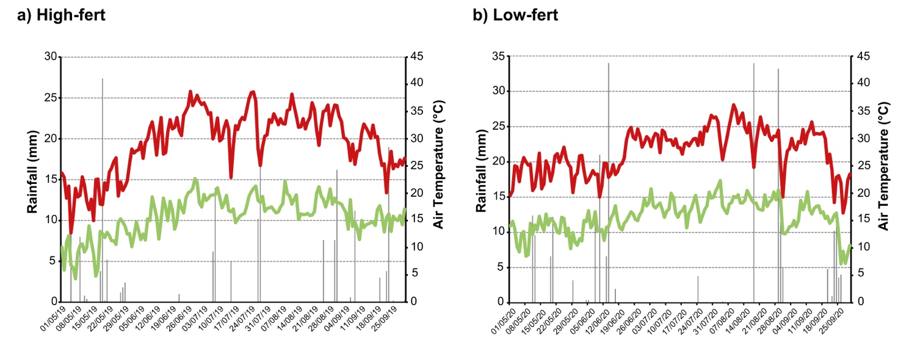

Fig. S1. Daily rainfall data and air maximum and minimum temperature during the growth cycle of sunflower (Helianthus annuus L.) at the high-fertility site (High-fert) (a) and at the low-fertility site (Low-fert) (b) in the experimental area within the farm “Azienda Agricola Musu Giuseppe e Francesco” Pisa, Italy. The rainfall gauge is located in Metato, San Giuliano Terme, Pisa Italy (E 16° 11’ 40’’ N 48° 47’ 38’’). The experiment at the High-Fert was run in 2019, while that at the Low-fert in 2020.
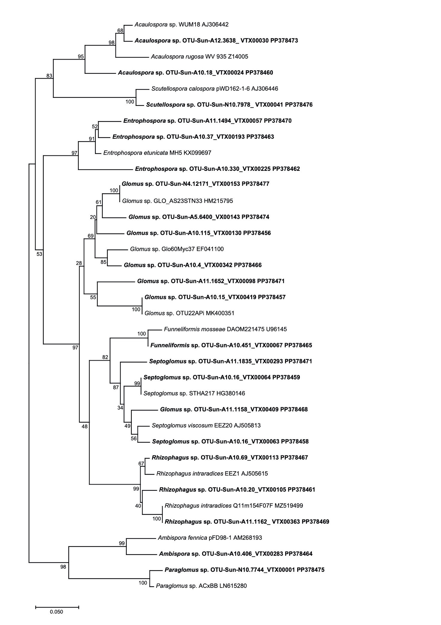

Fig. S2. Neighbor-Joining (NJ) (Saitou and Nei, 1987) tree of representative sequences of arbuscular mycorrhizal fungi (AMF; Glomeromycota) retrieved within the roots of sunflower (Helianthus annuus L.) inoculated in the high-fertility site by a local consortium of AMF and mock-inoculated. The NJ tree is based on the sequences obtained from the amplification of the small subunit ribosomal RNA (SSU) fragments amplified using a two-step nested PCR approach with two primer pairs (AML1/AML2 and WANDA-ill/AML2- ill) (Lee et al., 2008; Dumbrell et al., 2011). The taxa were assigned to Virtual Taxa (VTX) by BLAST against the MaarjAM database (https://maarjam.botany.ut.ee) (a total of 22 AM fungal VT belonging to six families). The analysis involved 36 sequences and was performed by 1,000 bootstrap replicates (Felsenstein, 1985) and the Kimura 2-parameter method (Kimura, 2021). Bootstrap values are shown. There was a total of 270 positions in the final dataset. Evolutionary analyses were conducted in MEGA11 (Tamura et al., 2021). Newly generated representative AM fungal sequences are in bold and VTX code is reported together with the ID code of the Operational Taxonomic Unit (OTU). The most similar AM fungal sequences from NCBI are included in the tree and for these sequences genus or species are reported in italic together with the isolate ID code and the NCBI accession number. All representative newly generated sequences (a total of 22) were deposited in the NCBI Sequence Read (SRA) database as SUB14264070 (accession numbers from PP378456 to PP378477).

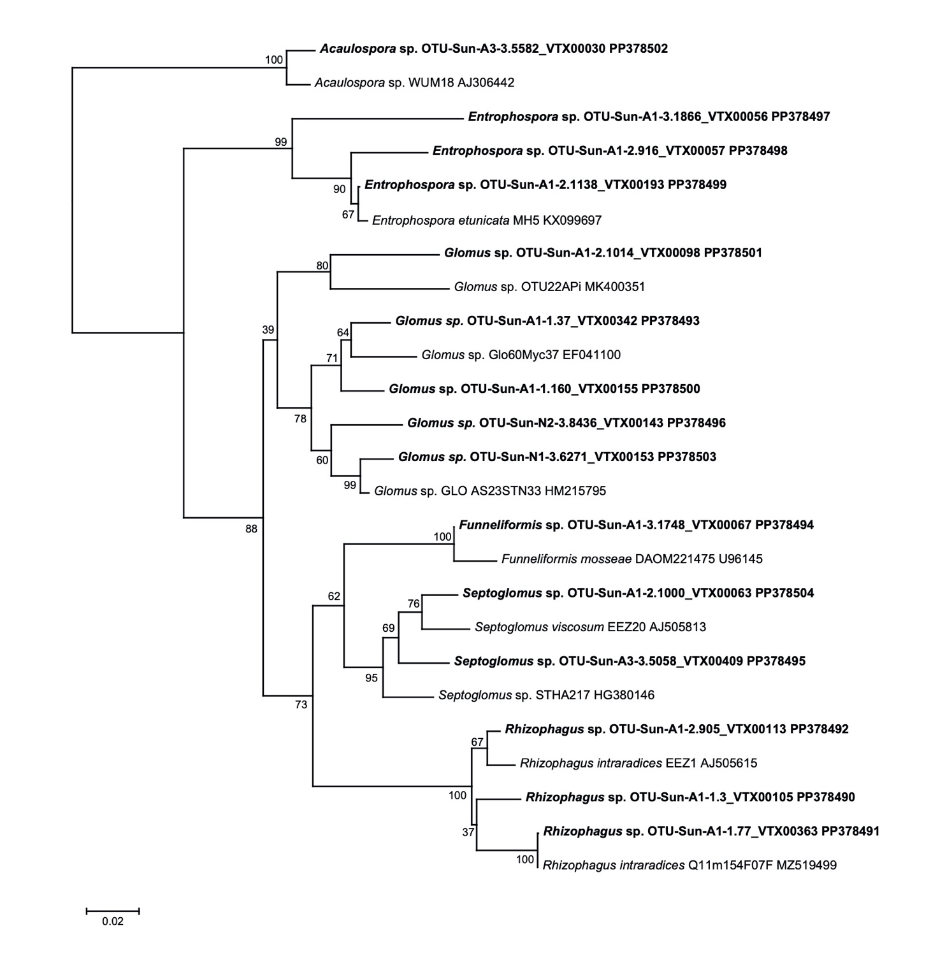

Fig. S3. Neighbor-Joining (NJ) (Saitou and Nei, 1987) tree of representative sequences arbuscular mycorrhizal fungi (AMF; Glomeromycota) retrieved within the roots of sunflower (Helianthus annuus L.) inoculated at the low-fertility site by a local consortium of AMF and mock inoculated. The NJ tree is based on the sequences obtained from the amplification of the small subunit ribosomal RNA (SSU) fragments amplified using a two-step nested PCR approach with two primer pairs (AML1/AML2 and WANDA-ill/AML2- ill) (Lee et al., 2008; Dumbrell et al., 2011). The taxa were assigned to Virtual Taxa (VTX) by BLAST against the MaarjAM database (https://maarjam.botany.ut.ee) (a total of 15 AM fungal VTX belonging to three families). The analysis involved 25 sequences and was performed by 1 000 bootstrap replicates (Felsenstein, 1985) and the Kimura 2-parameter method (Kimura, 2021). Bootstrap values are shown. There was a total of 268 positions in the final dataset. Evolutionary analyses were conducted in MEGA11 (Tamura et al., 2021). Newly generated representative AM fungal sequences are in bold and VTX code is reported together with the ID code of the Operational Taxonomic Unit (OTU). The most similar AM fungal sequences from NCBI are included in the tree and for these sequences genus and species are reported in italic together with the isolate ID code and the NCBI accession number. All representative newly generated sequences (a total of 15) were deposited in the NCBI Sequence Read (SRA) database as SUB14264075 (accession numbers from PP378490 to PP378504).

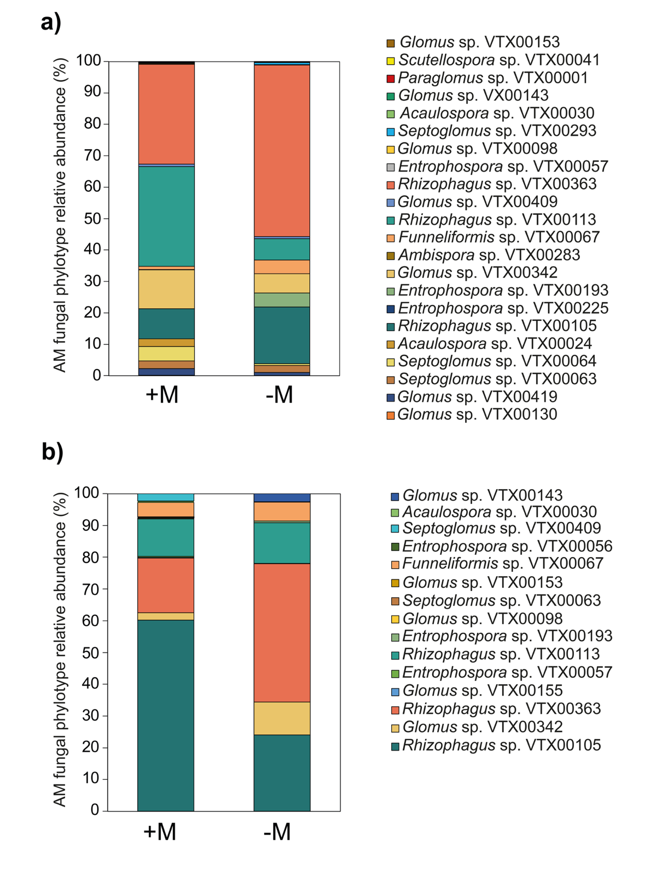

Fig. S4. Effect of arbuscular mycorrhizal fungal (AMF) inoculation on the relative abundance of AMF virtual taxa (VTX) at the high- and low fertility site (a and b, respectively). The experiment at High-Fert was run in 2019, while that at Low-fert in 2020. Treatments are: -M (mock-inoculation, control) and +M (inoculation by a local AMF consortium). Data of VTX were normalized to the median number of reads across the samples and then the relative abundances were calculated.

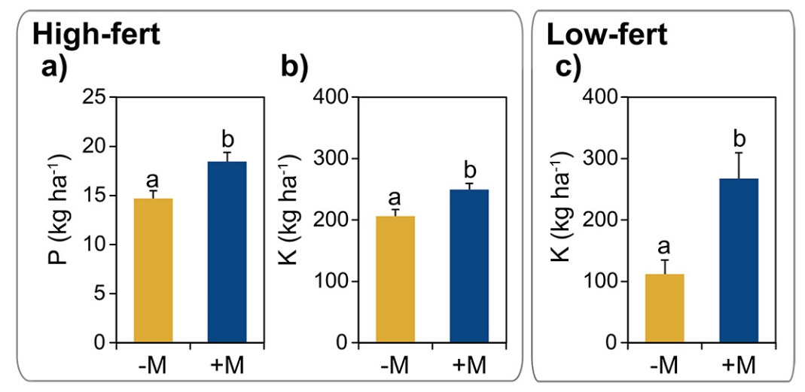
Fig. S5. Effect of arbuscular mycorrhizal fungal (AMF) inoculation on nutrient content in shoot of sunflower (Helianthus annuus L.) at R5.5 growth stage (beginning of anthesis): P (a) and K (b) at the high-fertility site (High-fert); K (c) at the low-fertility site (Low-fert). The experiments at High-fert and Low-fert were run in 2029 and 2020, respectively. Figure reports only the significant results of one-way ANOVAs. In the ANOVAs AMF inoculation was used as fixed factor (-M: mock inoculation, control; +M: inoculation by a local AMF consortium). Means ± SE of four and three replicate plot per treatment at High-fert and Low-fert, respectively. Nutrient measurements were based on shoots sampled from three areas of 1 m² for each replicate plot (a total of 24 and 18 samples in High-fert and Low-fert, respectively). Subreplicates were used as nested factor within the main factor AMF inoculation.

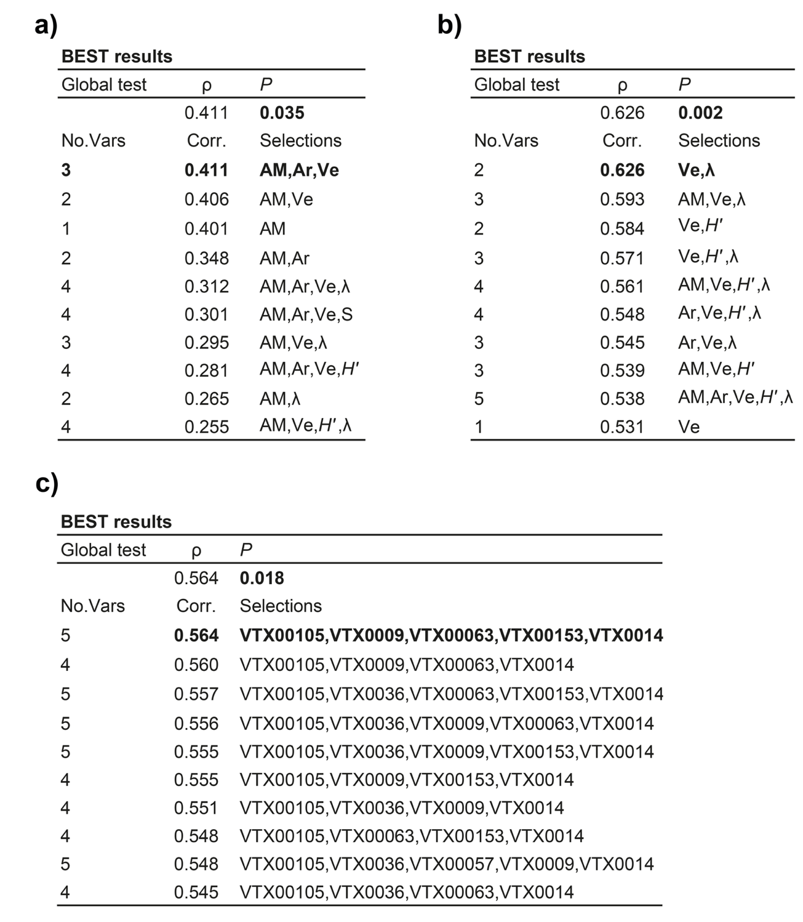

Fig. S6. Overall output of the BEST analysis (Clarke et al., 2008) used to find the best descriptor(s) of the relationships between fungal traits (i.e., AM fungal root colonization, arbuscules, vesicles, richness, Shannon and Simpson indices in roots) and plant functional traits (i.e., plant growth, grain and oil yield, shoot and grain nutrient contents) at the high-fertility site (a) and low-fertility site (b). The experiments at High-fert and Low-fert were run in 2029 and 2020, respectively. Results of the BEST analysis used to find the best descriptor(s) of the relationships between AM fungal community and plant functional traits at Low-fert 2020 (c). The BEST analysis was performed when the RELATE analysis (Clarke and Warwick, 2001) between the two matrices was significant. The BEST analysis was based on BioEnv methods (all combinations), Spearman rank and 999 permutations.

References

Clarke, K.R., Warwick, R., 2001. Change in marine communities: an approach to statistical analysis and interpretation. Plymouth: PRIMER-E.
Clarke, K.R., Somerfield, P.J., Gorley, R.N., 2008. Testing of null hypotheses in exploratory community analyses: similarity profiles and biota-environment linkage. J. Exp. Mar. Bio. Ecol. 366, 56–69. https://doi.org/10.1016/j.jembe.2008.07.009.
Dumbrell, A.J., Ashton, P.D., Aziz, N., Feng, G., Nelson, M., Dytham, C., Fitter, A.H., Helgason, T., 2011. Distinct seasonal assemblages of arbuscular mycorrhizal fungi revealed by massively parallel pyrosequencing. New Phytol. 190, 794-804. https://doi.org/10.1111/j.1469-8137.2010.03636.x.
Felsenstein, J., 1985. Confidence limits on phylogenies: An approach using the bootstrap. Evolution 39, 783-791. https://doi.org/10.1111/j.1558-5646.1985.tb00420.x.
Kimura, M., 1980. A simple method for estimating evolutionary rate of base substitutions through comparative studies of nucleotide sequences. J. Mol. Evol. 16, 111-120. https://doi.org/10.1007/BF01731581.
Lee, J., Lee, S., Young, J.P.W., 2008. Improved PCR primers for the detection and identification of arbuscular mycorrhizal fungi. FEMS Microbiol. Ecol. 65, 339-349. https://doi.org/10.1111/j.1574-6941.2008.00531.x
Saitou, N., Nei, M., 1987. The neighbor-joining method: A new method for reconstructing phylogenetic trees. Mol. Biol. Evol. 4, 406-425. https://doi.org/10.1093/oxfordjournals.molbev.a040454.
Schneiter, A.A., Miller, J.F., 1981. Description of sunflower growth stages 1. Crop Sci. 21, 901-903. https://doi.org/10.2135/cropsci1981.0011183X002100060024x.
Tamura, K., Stecher, G., and Kumar, S., 2021. MEGA 11: Molecular Evolutionary Genetics Analysis Version 11. Mol. Biol. Evol. 38, 3022-3027. https://doi.org/10.1093/molbev/msab120.

